Effie Armah-Tetteh
Staff ID: 4547189
investment portfolio modelling: london resdential properties

Executive Summary
This reports the development of a data-driven estimation engine to support residential property investment decisions in the London housing market. Using transaction, energy performance, and transport accessibility data, I train and compare multiple supervised learning models to predict property sale prices and to identify a portfolio of 200 properties with the highest expected investment returns.
The modelling pipeline combines rigorous data cleaning, exploratory analysis, feature selection, algorithmic tuning and statistical metrics on both training and validation sets to assess generalisation performance.
I compute expected profit margins by comparing predicted prices with asking prices, and construct the investment portfolio by applying conservative risk controls: excluding extreme predictions, enforcing minimum profit thresholds, and selecting the top-ranked opportunities by expected return.
Among the models tested, a tuned Gradient Boosting model provides the most reliable balance between predictive accuracy, robustness, and portfolio performance. Under the stated assumptions and filtering criteria, the selected portfolio yields a high expected average profit margin on the validation data: ≈73%. This estimate should be interpreted as a model-based expectation rather than a guaranteed outcome, and is sensitive to threshold choices and market conditions.
Finally, I outline how the estimation framework can be extended to assess whether proximity to the Elizabeth line (Crossrail) continues to present an incremental investment opportunity.

Contents
Introduction 2
Background 2
Problem Definition 2
Methodology 2
Data Acquisition and Cleaning 2
Exploratory Data Analysis 3
Data Modelling 4
Feature Selection 4
Model Experimentation 5
Linear Regression Models 5
Decision Tree 5
Tree-based Ensemble methods 5
Stacking 5
Model Interpretation and Results 6
Portfolio Curation 6
Extension 6
Elizabeth Line’s Effect on House Prices 6
Conclusion 7
Appendices 8
Appendix A: Exploratory Data Analysis Visualisation 8
A1: Intuitive Visualisations 8
A2: Further EDA 9
Appendix B: Feature Selection 10
B1: VIF, LassoCV Feature Selection, Permutation Importance 10
B2: Selected Features and Preprocessing 11
Appendix C: Model Results 12
C1: Supervised Learning Models Comparison 12
C2: Portfolio Profit Predictions 12

Introduction

Background
Since 1995, post-recession, London house prices have risen more than 5 times as fast as incomes, and well above general inflation. The UK economy growth rate, average income and house prices crashed during the country’s last two recession periods (1990-1992; 2007-2010). A question for investors therefore arises: in post-Brexit, post-Covid London – how will house prices change, according to observed economic trends?
In today’s London, there is much uncertainty which may affect the housing market, e.g.:
- As investments reduce, people speculate that lucrative jobs will move to Europe.
- UK government initiatives are in place to reduce the speed of increasing housing prices
- A weaker GBP makes UK property more attractive to foreign investors
None of these uncertainties can be viewed in isolation. To truly understand the change and direction of residential property prices in London, one must derive prediction power on house sales by using both local to global datapoints.
With a powerful predictive model, investors may not only determine whether investing in London housing is worthwhile, but more so exactly which investments would be worth their while.

Problem Definition
Investors seek to build an investment portfolio of 200 houses in London. Thus, the business challenge is a data integration and prediction problem: designing a scalable, reliable modelling approach that can predict the expected price of a residential property, using pertinent data points.

Methodology

Data Acquisition and Cleaning
The Data were drawn from three main sources: (i) Land Registry’s Price Paid Data for registered property sales in London; (ii) Energy Performance Certificate data on property features; (iii) Public Transport information from TfL. These tables were merged to create a unified dataframe.
It was prepared firstly by splitting it into a training dataset and a testing dataset. Then, any variables with datatype object were converted to categorical. I furthered this by converting the discrete numerical variables, like the London zone, into ordinal categorical variables.
Both datasets had several null values in the ‘town’ column and a few null values in population. I cleaned this by dropping the town column and dropping the observations with null population values, from both datasets. Further, the test dataset had empty columns for variables like ‘address_1’ and ‘local_authority,’ while its price was completely removed. From both datasets I removed the columns that were empty for the test dataset. However, I kept price in the training data to measure the accuracy of the supervised learning model predictions.
Next, I sense checked the training dataset by showing descriptive stats for the numerical variables and value counts for categorical. This highlighted certain outliers and disproportionate category sizes before interpreting the relationships via plots.
Finally, I denoted ‘price’ as the target variable and the others as feature variables for the training data. I split the training set into training and validation to derive overfitting metrics for the models, later.

Exploratory Data Analysis
Before modelling, I conducted EDA to further understand each feature, their relationships with price, and each other. First, I plotted a histogram and KDE plot of house prices to understand the distribution and the extent of outliers. I found that most residential properties sold in London in 2019 had an asking price around £500,000; the pricing is heavily right skewed with most properties being under £3,000,000 and outliers being as expensive as £10,000,000 or more. I also plotted scatter graphs and histograms for intuitive assumptions, which confirmed that house prices are more expensive when detached, closer to central London, and closer to a train station. This is intuitive from experiencing London culture; people prioritise a shorter and efficient commute to work, and need sufficient space for family, friends, consumption habits or all of the above.
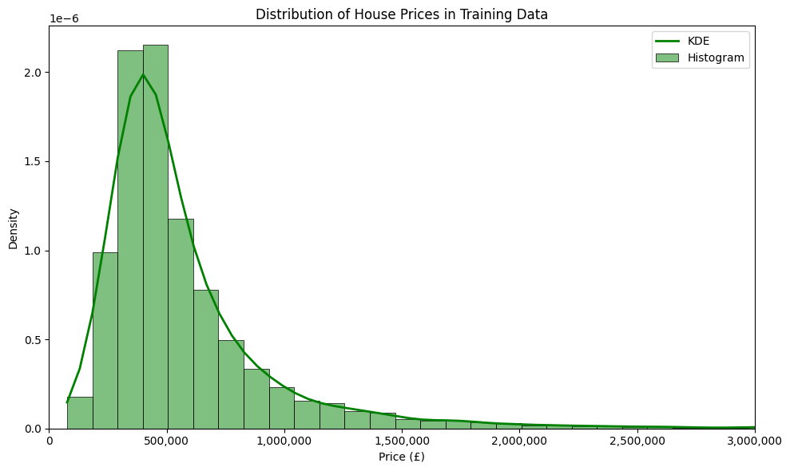

I then plotted relationships for which I had no assumptions. I found that, on average, the asking price of residences varied by water company, and that more expensive houses consume less energy but produce more CO2 per square metre. The former likely reflects geographic clustering, as water companies serve distinct regions that differ in income levels, housing stock age, and planning constraints, rather than the intrinsic quality of water services themselves. This is evidenced by the fact that Thames Water, who service ≈10/13 residences in the dataset, have the widest asking price range and the most outliers. Meanwhile, Leep Utilities service 7/1992 residences in the dataset, have the smallest range and no outliers. The latter is economically plausible. Higher-value homes are often larger, older properties with gas-based or oil-based heating systems, which emit more CO₂ per unit of energy than electricity. Simultaneously, wealthier households may invest in insulation, glazing, and efficient appliances, reducing energy consumption without proportionately lowering carbon intensity. This highlights the importance of distinguishing between energy efficiency and emissions intensity when modelling housing prices.
I then plotted a correlation matrix which showed that total floor area and co2 emission metrics have a strong, positive correlation with price while the energy metrics have a moderate, negative correlation with price. From these results I confirmed that they would be strong drivers of house prices. However, floor area and the co2 emission metrics are also strongly correlated, therefore I decided conduct thorough feature selection to confirm which variables can be dropped or combined.

Data Modelling
I first conducted thorough feature selection before experimenting with multiple models to see which best predicted the prices of the data.

Feature Selection
Feature selection was conducted using three complementary methods:
- VIF analysis to reduce multicollinearity;
- Lasso regularisation to identify sparse linear effects and interactions;
- Permutation importance to assess non-linear predictive relevance.
VIF analysis identified (i) unique explanatory power from distance to station and longitude (ii) severe multicollinearity among total floor area, energy consumption, and CO₂ metrics. Rather than retaining all correlated variables, I prioritised total floor area as the most economically interpretable proxy for size and maintenance burden. LassoCV confirmed that floor area dominates both as a standalone predictor and in interaction terms, while population, altitude, and redundant emissions variables contributed little incremental explanatory power once size and location were controlled for.
Permutation importance further validated these choices, ranking energy consumption potential as more predictive than current consumption, likely because it captures structural efficiency rather than occupant behaviour. Property type, whether the residence is old or new, whether it is a freehold or leasehold and water company also ranked highly. Based on consistency across methods, the final feature set balances interpretability, predictive power, and robustness to overfitting.
Elastic Net regularisation was initially explored due to its ability to balance feature selection and coefficient shrinkage. However, when applied to a high-dimensional interaction space with extensive categorical encoding, the computational cost was prohibitive relative to the marginal performance gains once feature selection had already been robustly addressed.
In concluding feature selection, I saved the lists of selected numerical variables and categorical variables separately, for ease of use in subsequent modelling. Ultimately, the feature selection method show that floor area, categorical location variables and energy consumption potential are the most important predictors of price. Combining these results led to a parsimonious yet expressive feature set that reduces variance without sacrificing predictive accuracy.

Model Experimentation

Linear Regression Models
The baseline linear regression achieves moderate explanatory power (training R² ≈ 0.69) but exhibits large absolute prediction errors, with an RMSE close to £0.5 million. When evaluated on the validation set, the model’s RMSE decreased to £253,000 with an R² of 0.71
Although the R² improvement suggests limited overfitting, the absolute prediction error remains economically large relative to typical property prices. As such, relying on this model for investment selection would expose investors to substantial downside risk.
Ridge regularisation improves stability by shrinking coefficients in the presence of multicollinearity, resulting in modest gains in validation performance. I derived the alpha for the RidgeCV regressor, to facilitate tuning them in a stacking ensemble later. I similarly noted the optimised hyperparameters for the subsequent models for ease of final model parameters.
However, the improvement is incremental rather than transformational. These results suggest that linear structure alone is insufficient to capture the complex, non-linear price dynamics of London housing.

Decision Tree
Next, I ran a decision tree with my selected features and tuned it to get the best hyperparameters. It marginally outperformed the linear models on both testing and validation sets; its RMSEs were around similar while the difference in R² gap was small, confirming that feature selection was robust. Nonetheless, the predictive power was still only ≈0.73, which suggested that it need to be regularised with ensemble methods.

Tree-based ensemble methods
Tree-based ensemble methods substantially outperform the linear and decision tree benchmarks. Gradient Boosting delivers the strongest balance between predictive accuracy and generalisation, achieving high explanatory power on both training and validation data with a negligible overfitting gap. Random Forest performs similarly but with slightly higher variance, while XGBoost marginally improves training accuracy at the cost of increased overfitting.

Stacking
Finally, Stacking further improves performance by combining complementary model strengths. The Elastic Net meta-learner assigns higher weights to boosting-based models, confirming that non-linear learners drive predictive gains. However, the incremental improvement over Gradient Boosting alone is small, suggesting diminishing returns from additional model complexity.

Model Interpretation and Results
The business objective is to pick the top 200 houses that will maximise investment return. The baseline validation must be the statistical model performance on the held-out (testing and validation) datasets. The RMSE and R^2 metrics ensure predictive reliability and guard against overfitting.
For investors, predictive accuracy is translated to the average ROI of the portfolio. I calculate the expected profit margins of each property as:
$$\frac{predicted price-asking price}{asking price}$$
To control downside risk, I exclude properties with extreme predictions and impose a minimum expected profit threshold. This avoids concentrating capital in high-variance forecasts that could disproportionately harm portfolio returns. The final portfolio consists of the top 200 properties ranked by average expected profit, subject to these constraints.
Given the business objective of robust out-of-sample profitability rather than maximal in-sample fit, Gradient Boosting is selected as the final model.

Portfolio Curation
To choose the top 200 houses to invest in, I predicted house prices on the testing data set using my tuned Gradient Boosting model and selected features. Then, I excluded the extreme predictions, by selecting predictions within 90% of the median prediction price, to mitigate high-risk exposure for investors. I also established a minimum expected profit margin threshold to ensure that the selected properties offer sufficient margin to absorb prediction error.
With the prices predicted and filtered, I created a subset of the top 200 by selecting the top 200 by their expected profit. To translate this clearly to investors, I added a “buy” column to the dataset; selected properties have a value of 1 in the “buy” column.
Finally, I created a summary table comparing each model on the following performance metrics: Train RMSE, Train R², Validation RMSE, Validation R², Overfit gap, Average profit %, Top 200 profit%. I checked the robustness my portfolio by calculating the mean and median profit margins, which are very similar to the mean and median profit margins derived from the validation set, thus confirming minimal overfitting.

Extension

Elizabeth Line’s Effect on House Prices

Is there still a profit opportunity to invest in neighbourhoods that will be served by Crossrail?
This question is relevant to investors because data shows that properties near the Elizabeth line stations have historically outperformed the market; their prices have been less sensitive to housing market fluctuations and delays, while their prices have significantly increased in comparison to areas not benefitting from the line, since the route was announced. So, the immediate response is yes – but how significant is that profit opportunity? Should we adjust the portfolio for it?
My tuned gradient boosting model, with an additional feature, would be able to answer these subsequent questions. I assume that to truly benefit from proximity to stations that have the Elizabeth line, residential properties need to be within a certain walking radius e.g. 20 minutes. So, I would add a binary variable like ‘near_lizzy_line’ to my model.
To assess the importance of proximity to the Elizabeth line, I would predict prices for both subsets of the ‘near_lizzy_line’ variable and compare their profit margins. If the ‘near_lizzy_line’ == 1 properties have higher expected profit margins, or a larger share of high-profit properties, then it suggests that the profit opportunity remains. As such, the portfolio should be edited to recognise this niche segment of London residences.

Conclusion
This analysis demonstrates that ensemble tree-based models, particularly Gradient Boosting, provide a scalable and robust framework for predicting London house prices in a complex, heterogeneous market. Through careful feature selection, regularisation, and validation, the final model achieves strong predictive accuracy while controlling for overfitting.
Based on validation-set simulations, the selected portfolio achieves a mean expected profit margin of approximately 73%. This figure should be interpreted as a model-based estimate under historical market conditions, rather than a guaranteed or risk-free return. The distribution of profits is right-skewed, evidenced by the substantially lower median profit margin (approximately 55%), with a small number of high-performing properties contributing disproportionately to the average. This reinforces the need for conservative filtering and highlights the uncertainty inherent in property investment decisions.
Overall, the modelling framework prioritises generalisation, interpretability, and portfolio-level robustness, ensuring that investment decisions are driven by economically meaningful signals rather than overfitted predictions. However, it does not account for the effect external market conditions on housing prices.
Model enhancements could include both macroeconomic indicators and niche transport infrastructure effects, e.g. the ‘near_lizzy_line’ variable to spotlight the properties whose prices are more robust as part of this trend. Training the model with these additional variables would improve both predictive accuracy and investment relevance.

Appendices

Appendix A: Exploratory Data Analysis Visualisation

A.1. Intuitive relationships
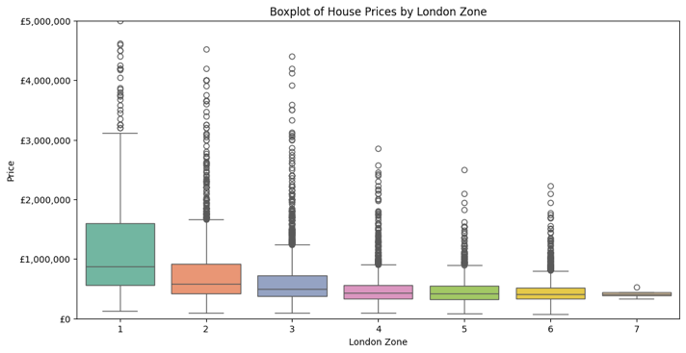
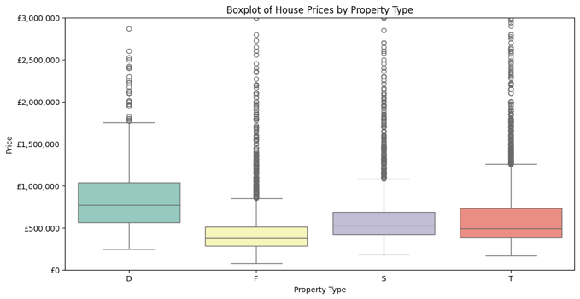
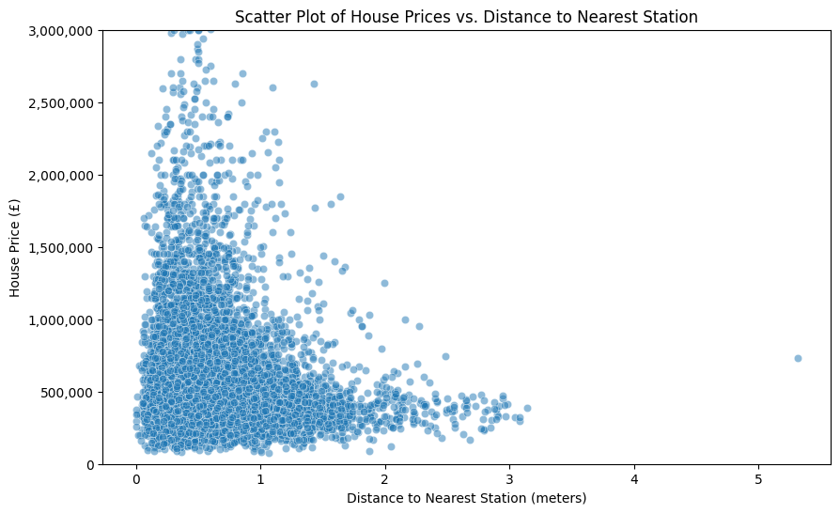

A.2. Further EDA exploration
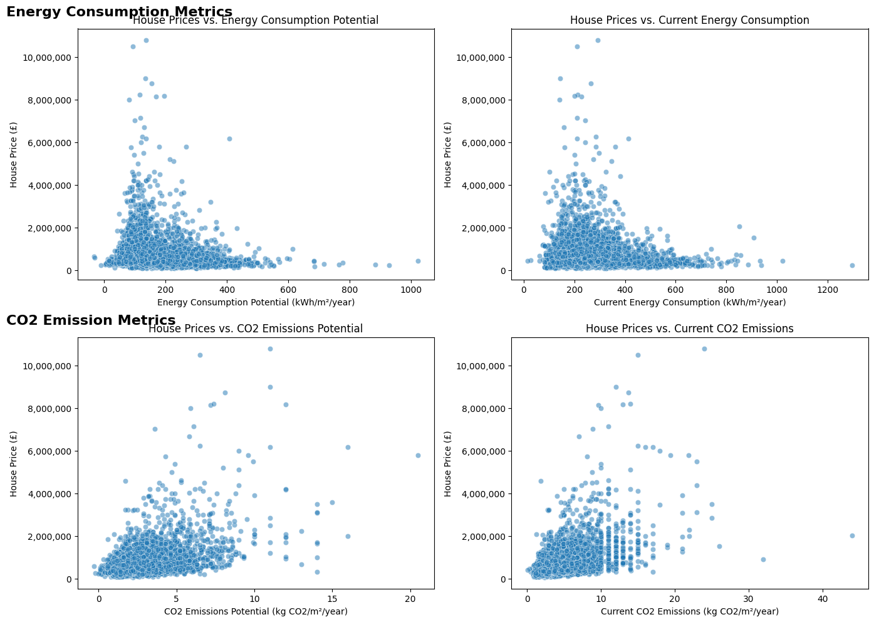
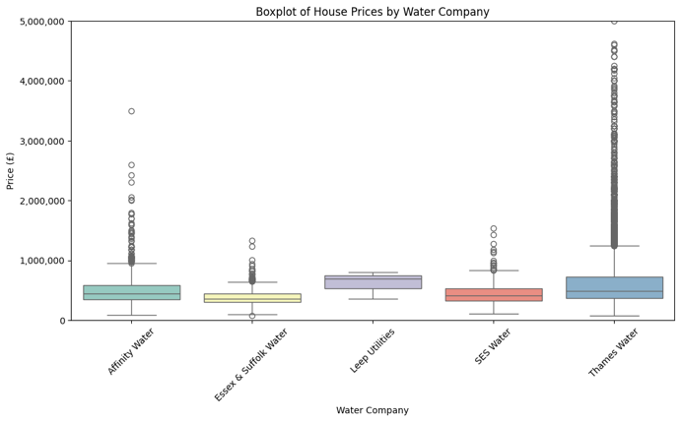

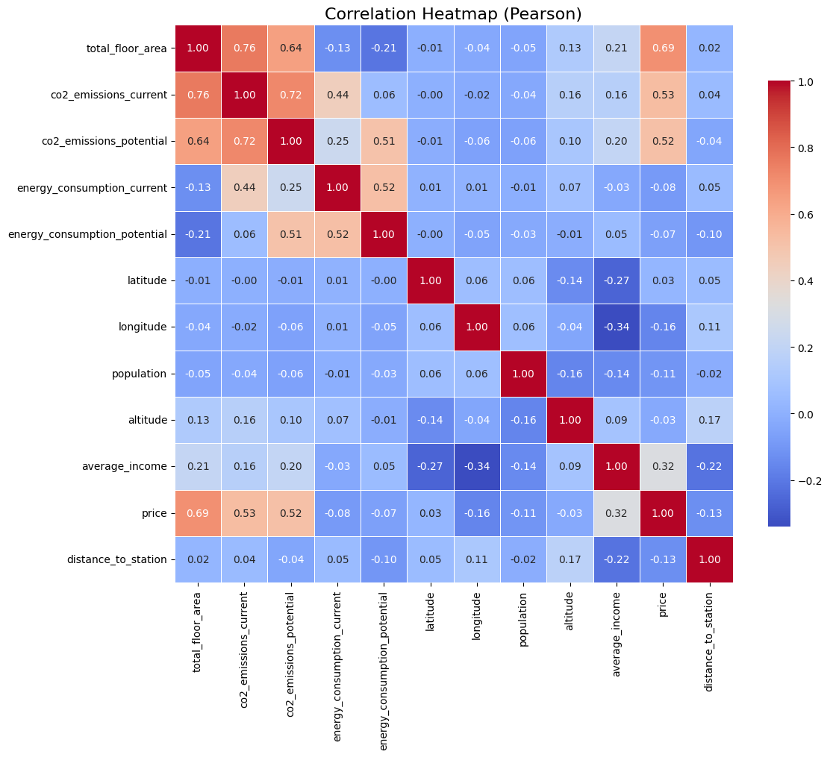

Appendix B: Feature Selection

B.1. VIF table, LassoCV Feature Selection, Permutation Importance
feature VIF
0 distance_to_station 4.004569
1 latitude 94.661101
2 longitude 1.657243
3 average_income 55.881640
4 altitude 3.254881
5 energy_consumption_potential 29.203499
6 energy_consumption_current 52.051880
7 co2_emissions_potential 34.026423
8 co2_emissions_current 51.722158
9 total_floor_area 36.871001
10 population 4.856329

Appendix C:
X
Importance

cat__district_Kensington and Chelsea: 598392.1307
cat__london_zone_1: 451893.5680
cat__postcode_short_SW1X: 402949.8212
cat__postcode_short_SW3: 343800.6764
cat__district_Westminster: 276968.7153
cat__postcode_short_W14: -219709.4324
num__total_floor_area: 208781.2060
cat__london_zone_2: 200954.6512
cat__postcode_short_NW3: 139861.9096
cat__london_zone_3: 81471.4815
cat__district_Hammersmith and Fulham: 71209.2006
num__altitude total_floor_area: -61847.9357
num__average_income: 56900.6661
cat__postcode_short_SW6: 49089.0836
cat__district_Camden: 46127.6170
cat__district_Croydon: -45333.0097
num__total_floor_area population: -42129.4749
num__co2_emissions_potential: 41849.2223
num__co2_emissions_current total_floor_area: 40087.7126
num__average_income total_floor_area: 35841.9987

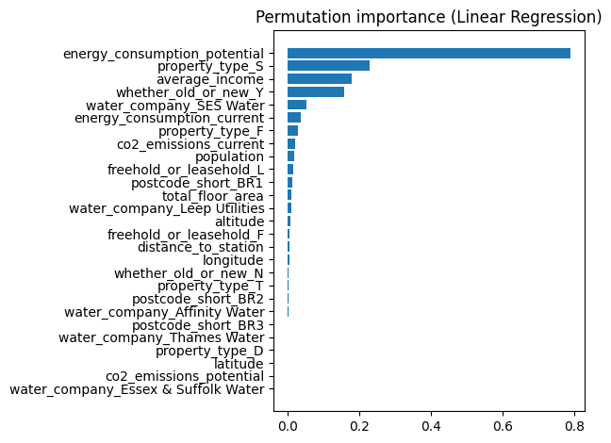

B.2. Selected Features with Preprocessing
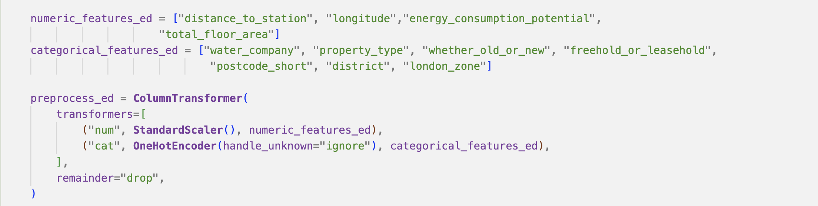

Appendix C: Model Results

C.1. Supervised Learning Models Comparison

 | Model | Train RMSE | Train R² | Validation RMSE | Val. R² | Overfitting Gap | Mean profit (Val) % | Median profit (Val) % | Mean profit (Top 200, Val) % | Median profit (Top 200, Val) %
2 | Decision Tree | 258389.579 | 0.769 | 233574.349 | 0.754 | 0.015 | 6.11 | 1.61 | 81.420876 | 66.4872  91
0 | Linear Reg | 282384.014 | 0.721 | 252778.786 | 0.711 | 0.009 | 1.40 | -1.66 | 73.900035 | 62.883367
3 | Gradient Boosting | 213333.769 | 0.840 | 186091.524 | 0.844 | -0.003 | 5.78 | 1.47 | 71.727868 | 56.814791
4 | Random Forest | 215089.048 | 0.837 | 199857.068 | 0.820 | 0.017 | 4.93 | 0.71 | 69.971883 | 54.603254
1 | RidgeCV Reg | 272604.817 | 0.740 | 247938.927 | 0.722 | 0.017 | 1.56 | -1.94 | 69.451357 | 59.532380
5 | XGBoost | 202873.895 | 0.856 | 195970.830 | 0.827 | 0.029 | 4.53 | 0.35 | 66.463561 | 52.125174
6 | Stacking | 198832.651 | 0.861 | 185181.927 | 0.845 | 0.016 | 4.35 | 0.63 | 66.355422 | 51.306876

C.2. Portfolio Profit Predictions
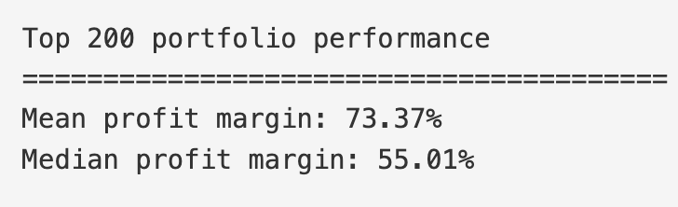

Appendix A.1.
Appendix A.2.
Metrics refers to the two sub-variables for CO2 and or Energy: potential and current
Appendix B.1
postcode short, London zone, and district ranked highly as standalone features
Appendix B.2
[Mansion Global (2023) It’s not too late for investors to get in on a London Crossrail boon. Available at: https://www.mansionglobal.com/articles/its-not-too-late-for-investors-to-get-in-on-a-london-crossrail-boon-211194 (Accessed: [18/12/25])

